Abstract:
The Password Lock System is a digital electronic security project designed to restrict access to authorized users through a password verification mechanism. The system is implemented using an Arduino microcontroller, a 4×4 keypad for user input, a 16×2 LCD display for interaction, a servo motor to act as the lock mechanism, and a buzzer for security alerts.
When a user enters a password through the keypad, the system compares the entered code with a pre-stored password in the microcontroller’s memory. If the password matches, the LCD displays an “Access Granted” message and the servo motor rotates to unlock the system. In case of a wrong password, the LCD displays “Access Denied” and the buzzer produces an alert sound, ensuring immediate feedback to the user.
This project demonstrates the application of microcontroller-based systems in enhancing digital security. It is low-cost, reliable, and can be further improved by adding features such as multiple user passwords, changeable password storage, or integration with IoT modules for remote access. The Password Lock System can be widely used in homes, offices, laboratories, and other areas where secure access is required.

Introduction:
In today’s world, the need for reliable and secure access control systems is rapidly increasing. Traditional lock-and-key mechanisms are gradually being replaced by digital alternatives that provide higher security and convenience. One such solution is the Password Lock System, a digital electronic project that uses a microcontroller to verify user identity through a password.
The system employs a keypad for password entry, an LCD display for user interaction, a servo motor to represent the locking mechanism, and a buzzer to alert in case of unauthorized access. When the correct password is entered, the lock opens temporarily, allowing access. If the password entered is incorrect, the system denies access and activates the buzzer to alert the user.
This project demonstrates how microcontrollers can be used to design efficient and cost-effective security systems. It integrates both hardware and software to achieve reliable access control and can be adapted for real-world applications such as door locks, safes, and restricted areas. By combining digital electronics with embedded programming, the Password Lock System highlights the importance of automation in modern security solutions.

Background of the Study
Security and controlled access have always been important aspects of daily life, from safeguarding personal belongings to ensuring the safety of homes, offices, and laboratories. Traditional mechanical locks and keys, although widely used, are prone to disadvantages such as duplication of keys, misplacement, and wear over time. With advancements in digital electronics and embedded systems, microcontroller-based security systems have emerged as reliable, flexible, and cost-effective solutions. The Password Lock System is one such application, combining digital hardware with software logic to create an efficient electronic lock controlled by a password. This project makes use of a keypad for password entry, a microcontroller for processing, and actuators such as a servo motor and buzzer for output response.
Problem Statement
- Conventional locks are vulnerable to unauthorized access due to key duplication, theft, or loss.
- In areas requiring strict access control, traditional systems do not provide adequate reliability or flexibility.
- There is a need for a low-cost, user-friendly, and customizable security solution.
- A system based on password authentication can provide better protection than physical keys.
- The main challenge is to design a digital electronic lock that can:
  - Accurately verify user credentials
  - Provide immediate feedback through display and alerts
  - Minimize risks of unauthorized entry.

Literature survey
Article1: Password Based Door Lock System
Authors: Prof.A.Y.Prabhakar1,Prof. Dr. Shruti K Oza, Nayan Shrivastava, Prakhar Srivastava, Garvit Wadhwa
https://d1wqtxts1xzle7.cloudfront.net/59826787/IRJET-V6I222520190621-5073-18m6ehf-libre.pdf?1561186847=&response-content-disposition=inline%3B+filename%3DIRJET_V6I.pdf&Expires=1756461421&Signature=bEXFWVH~-yt2vk6~hQd60yyCkk5A62EXicIDl7NXwP05k5X6Mylo3WXdWTUIOZ~N4quF5B5~Q2tRk-iXYgSJAfxlvQOMKGGXH~iZ~xTxnb5qaWMY6K1XTf4bBGu~CvMFp0Tuin5uvxS4dlzFBtv0DyitwaTH2Smtd5AKWoBgv0nfe~I4GgGBJDoj-eQfKOKt1H7uOLiE~Df1KkUEZWvQ1jNNF52Cknx-BKgfc7k90mZJH243OLybCLWsYDGZ5BgPUGDd3qJpcZnuktPbuf07HdMPB6GNuX5iOPh~Kcxo65E28elbo7r3FGJwyn~1M7HhQREOIG47OXlPmZGKJ5HKyQ__&Key-Pair-Id=APKAJLOHF5GGSLRBV4ZA
A Password Based Door Lock System is an electronic security system designed to control door access using a secret code instead of traditional mechanical keys. In this system, a microcontroller such as Arduino or ESP32 is connected to an input device like a keypad where the user enters the password. The entered code is compared with the pre-stored password in the microcontroller’s memory. If the password matches, the system activates a locking mechanism, usually a servo motor or solenoid lock, which unlocks the door for a few seconds before locking it again automatically. If the wrong password is entered, the system denies access and may trigger a buzzer or an alarm. After several incorrect attempts, it can even enter a lockout mode to enhance security.
This system is simple, cost-effective, and user-friendly, making it a suitable replacement for traditional locks. It eliminates the problem of lost or duplicated keys since access depends only on knowing the correct password. The design can be further enhanced with features such as password change options, LCD/OLED displays for status messages, multiple user passwords, and IoT connectivity for remote access and monitoring. Overall, the password based door lock system provides a practical and reliable solution for smart homes, offices, and secure areas.

Article2: Automated Password Protected Door LockSystem
Authors: Shruti Goswami, Anirban Choudhury , Srijan Das , Tushit Banerjee , SohamGhosh
https://aiem.com.my/archives/2017/1/48-52.pdf
In the modern world, home and office security has become a top priority. Traditional locks with physical keys are slowly being replaced by smart electronic systems that offer more safety and convenience. An automated password protected door lock system is one such innovation that combines automation with security to control access effectively. The system works on a simple principle: only users who know the correct password can open the door. A keypad is provided for entering the password, and the entered digits are compared with a password stored inside a microcontroller. If the password matches, the system automatically activates a motor or solenoid to unlock the door. At the same time, a message like “Access Granted” appears on the display. If the password is incorrect, the system denies entry, shows “Access Denied,” and may activate a buzzer as a warning. To prevent misuse, the system can be programmed to lock itself after multiple wrong attempts. The hardware typically includes a microcontroller (such as Arduino, PIC, or 8051), a keypad, an LCD display, a motor driver circuit connected to the door lock, and a buzzer. The automation feature ensures that the door opens and closes automatically without requiring manual turning of a key or bolt. This system finds applications in residential houses, offices, hotel rooms, bank lockers, and other restricted areas where secure access is important. It is more reliable than mechanical locks, easy to operate, and can be enhanced by adding advanced technologies such as RFID cards, biometric sensors, or smartphone control.

Article 3: Password Protected Electronic Lock System for Smart Home Security
Authors: Md. Maksudur Rahman , Dr. Mohammed Sowket Ali & Md. Shoaib Akther
Password Protected Electronic Lock System for Smart Home Security
In recent years, smart home technology has gained great importance as people look for safer and more convenient ways to protect their homes. One such innovation is the password protected electronic lock system, which replaces traditional keys with digital security. In this system, the user enters a password through a keypad, and the microcontroller checks if it matches the stored code. If correct, the lock opens automatically; if not, access is denied, and a buzzer may sound as a warning. The system usually consists of a microcontroller, keypad, LCD display, relay driver, and solenoid lock. It can also be connected to alarms for better protection. Compared to mechanical locks, this method provides higher security since only authorized users with the correct password can open the door. It is also more convenient, as there is no need to carry physical keys. This electronic lock is very useful for smart homes, offices, hotels, and banks where secure access is important. It is cost-effective, reliable, and easy to operate. Additionally, it can be upgraded with advanced features like mobile phone control, fingerprint scanning, or IoT connectivity for remote monitoring.

Article 4: Password Protected Lock System Designed using Microcontroller
Authors: Aarfin Ashraf , Deepak Rasaily , Anita Dahal
https://d1wqtxts1xzle7.cloudfront.net/55668401/IJETT-V32P235-libre.pdf?1517295166=&response-content-disposition=inline%3B+filename%3DPassword_Protected_Lock_System_Desgined.pdf&Expires=1758093220&Signature=NrxYhZHBmgttArL1w5Yhmp8orXH8PwkgTIHj-nVgho00GRc6Oy9C91k-0vnvGVUVVyRGlNaFFszNd6Zo4T3B6twSo4t4iRkmCt6lESNiXSBSOj1M5NLB0zDCdOMFgKiweR9IABHZZeMVvVR1k0h9Q9JGCzuKM6Fg7h5iXQ6tm5YYsyOpBmu40tcTdLP~aBWx~4yacnBk6IW8gjf34ipCVg4lHN-d3hcsUpx6YOT1g~AE5Dtpjqh~VKN1F9GHV3bm6dRTz7qjoAG0jQr65K~kEzQhTUYzQz5JD4hq~m3ghJp8RWSU7yjlf1kqFzMzZTSoRXqNXVakBilzpvreT7-dzA__&Key-Pair-Id=APKAJLOHF5GGSLRBV4ZA

Security is one of the most important needs in our daily life. We all want our homes, offices, and valuable belongings to be safe. Traditional locks with keys have been used for many years, but they are not always reliable. Keys can be lost, stolen, or duplicated, which makes them risky. To solve this problem, modern electronic locks have been developed. One popular solution is the password protected lock system that works with a microcontroller. This system is very simple to understand. Instead of using a key, the user enters a password on a keypad. A small computer chip called a microcontroller checks the entered password. If the password is correct, the system gives permission to open the lock. If the password is wrong, access is denied and sometimes a buzzer makes a sound to warn about the wrong attempt. For more security, the system can even block itself after a few wrong tries. The system usually has a keypad for entering numbers, an LCD screen to show messages like “Enter Password” or “Access Granted,” a relay connected to the lock, and a buzzer for alerts. All of these are controlled by the microcontroller, which acts like the brain of the system.
Password protected locks are widely used in many places. They can be found in digital door locks at homes and hotels, lockers in banks, and even in smart home systems. They are safer than mechanical locks, easy to use, and can be upgraded with extra features like Wi-Fi or fingerprint sensors.

Article 5: Password Protected Home Automation System with Automatic Door Lock
Authors: Ankit Jain, Dr. Anita Shukla & Ritu Rajan
https://www.mitpublications.org/yellow_images/1452158122_logo_28-31.pdf
This paper presents a low-cost password-protected home automation system integrated with an automatic door lock. The system uses an Arduino UNO microcontroller connected to a keypad, relay, DC motor, and LCD display. By entering the correct password through the keypad, the system unlocks the door and simultaneously operates appliances like lights and fans. If the entered password is incorrect, access is denied, preventing unauthorized use.
The system enhances security by allowing the user to change or reset the password with a single key press, ensuring flexibility and reliability. It is designed to be simple, affordable, and user-friendly, making it suitable for modern home security and automation. The password protection prevents unauthorized access, while automation improves convenience.
Future improvements include integrating GSM modules so that alerts or calls can be sent to security personnel in case of repeated wrong password attempts. Overall, this system provides a cost-effective, reliable, and practical solution for smart home security and appliance control

Article6: Feasibility Study of Implementation of Cell Phone Controlled, Password Protected Door Locking System
Author : Ashish Jadhav , Mahesh Kumbhar , Mahesh Walunjkar
A cell phone controlled, password protected door locking system is an advanced security solution that combines mobile communication and microcontroller-based automation. The purpose of this system is to replace traditional key locks, which are often unreliable due to the risk of duplication, loss, or theft, with a more secure and convenient method. In this system, the user can control the door lock through a mobile phone using Bluetooth, GSM, or Wi-Fi technology, and at the same time, a password entry is required for double-layer protection. From a technical point of view, this project is highly feasible because modern microcontrollers such as Arduino, PIC, or ESP32 can easily interface with wireless modules and handle password verification. The hardware components, including a keypad, LCD display, relay driver, and solenoid lock, are low-cost and widely available, making implementation straightforward. Economically, this system is affordable compared to biometric or RFID-based security systems since it uses simple and inexpensive electronic parts, while the maintenance costs are minimal. Operationally, it is user-friendly, as most people are already familiar with smartphones and keypad entry systems, and it can be easily installed in homes, offices, hotels, and banks. Socially, it improves confidence in personal and property safety, supports the trend of smart living, and is likely to be widely accepted due to its convenience and reliability. Furthermore, the system can be upgraded in the future with features like fingerprint sensors, facial recognition, or integration with IoT devices for remote access and monitoring. In conclusion, the cell phone controlled, password protected door locking system is not only technically achievable and cost-effective but also practical, reliable, and beneficial for modern security applications.

DESIGN
Components:
User → 4×4 Keypad → Arduino UNO:
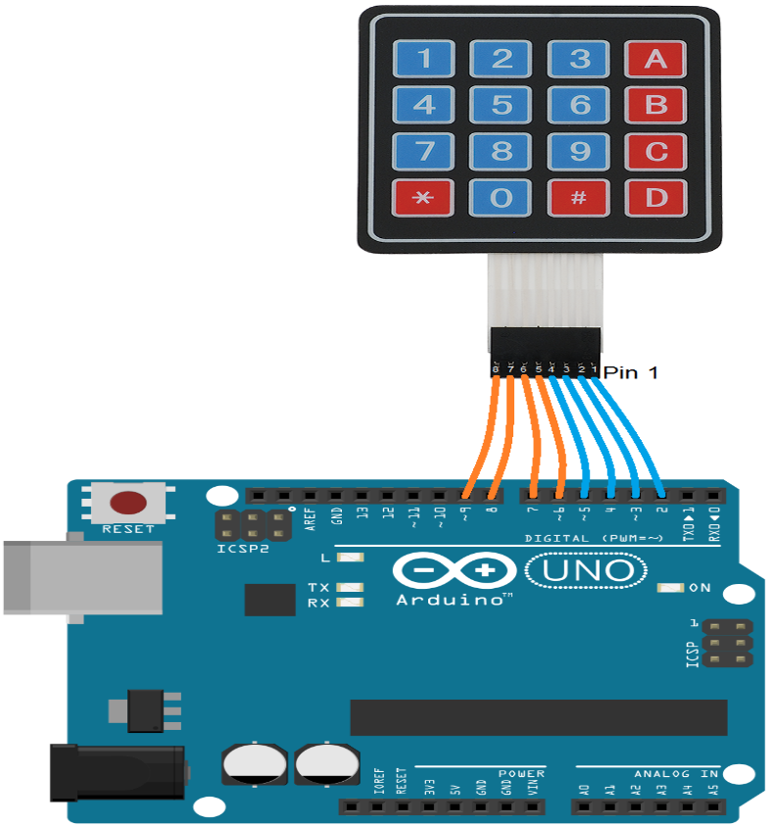

The 4×4 matrix keypad is the primary input device used in the Password Lock System. It consists of 16 push buttons arranged in a 4-row by 4-column matrix, which allows the user to enter digits (0–9) and special characters such as A–D, *, and #. Instead of requiring 16 separate connections, the keypad uses a row-and-column scanning technique that reduces the number of Arduino pins needed to just eight. When a key is pressed, it connects a specific row and column, and the Arduino detects this input through the Keypad library. In this project, the keypad is used for entering the password, where # or D serves as the “Enter” key to submit the input, and * is used to clear the current entry. The keypad is reliable, inexpensive, and easy to interface with Arduino, making it an ideal component for implementing password-based access control.

Arduino → 16×2 I2C LCD:

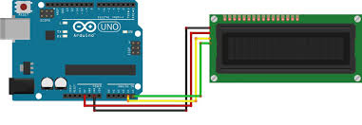
The 16×2 I2C LCD display is used in the Password Lock System to provide user interaction and feedback. It can display two lines of text with up to 16 characters per line, which is sufficient for showing prompts, entered passwords (masked as *), and system messages such as “Access Granted” or “Access Denied.” Unlike a standard parallel LCD that requires multiple digital pins, the I2C version uses only two communication lines—SDA and SCL—allowing easier wiring and leaving more pins available on the Arduino for other components. The display is essential in guiding the user during password entry and confirming the system’s status, thereby improving usability and reliability of the lock system.

Servo motor (e.g., SG90):

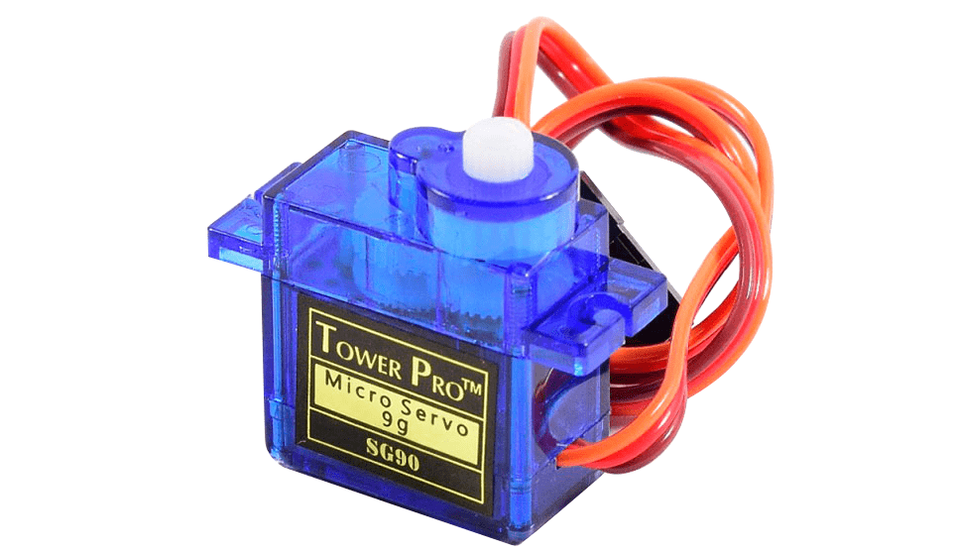
The SG90 servo motor is a compact and lightweight actuator commonly used in electronic projects for precise angular movement. It is capable of rotating its shaft within a range of 0° to 180°, controlled by sending pulse-width modulation (PWM) signals from the Arduino. In the Password Lock System, the SG90 servo acts as the locking mechanism: when the correct password is entered, the servo rotates to the unlock position, and after a short delay, it returns to the locked position. The SG90 is ideal for this project due to its small size, low power consumption, affordability, and ease of interfacing with microcontrollers, making it a practical choice for simulating electronic locks.
Piezo buzzer (active/passive)
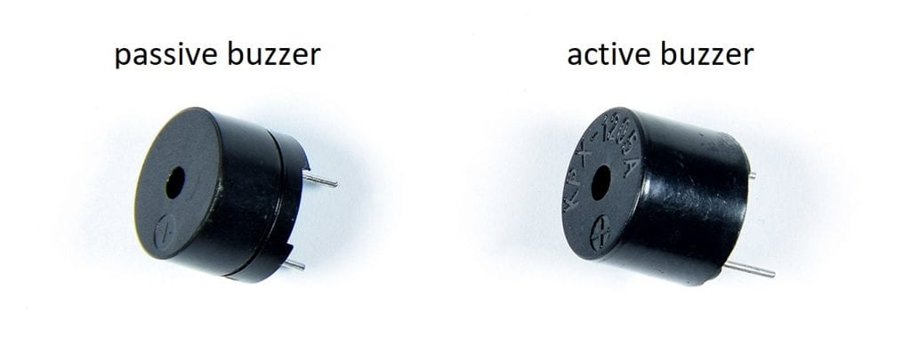
The piezo buzzer is a simple audio output device that generates sound through the vibration of a piezoelectric element when a voltage is applied. Buzzers are available in two types: active and passive. An active buzzer produces a continuous tone when powered, while a passive buzzer requires pulse-width modulation (PWM) signals from the microcontroller to generate different tones. In the Password Lock System, the buzzer is used to provide audio feedback, particularly to alert the user when an incorrect password is entered or to indicate unauthorized access attempts. Due to its low cost, small size, and easy integration with the Arduino, the piezo buzzer is an effective component for enhancing the system’s interactivity and security features.

LEDs (green/red) + resistors
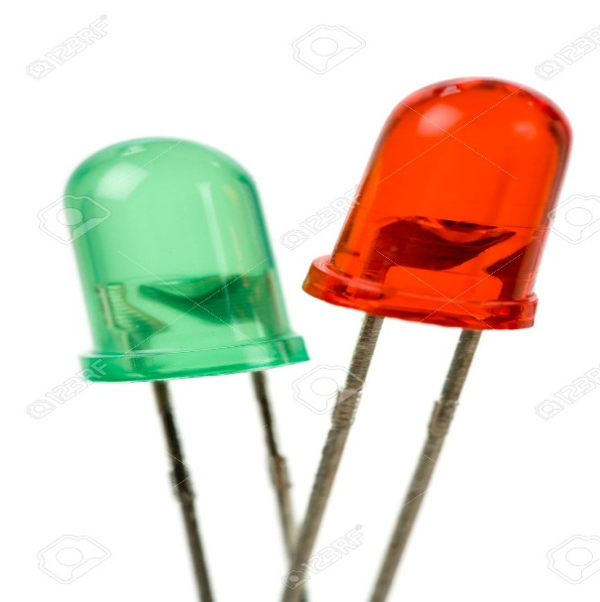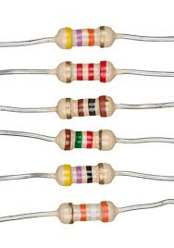
The LED indicators play an important role in visually communicating the status of the Password Lock System. A green LED is typically used to signal successful password entry and access granted, while a red LED indicates a wrong password attempt or access denial. These LEDs are connected to the Arduino through current-limiting resistors (usually 220Ω to 330Ω) to prevent excessive current flow that could damage the LEDs. By providing clear visual feedback alongside the LCD and buzzer, the green and red LEDs enhance the usability of the system and make it easier for users to quickly recognize whether access has been approved or denied.

Power supply
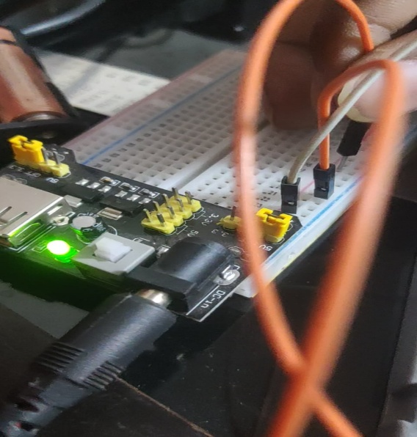
The power supply is a crucial part of the Password Lock System, ensuring stable and reliable operation of all electronic components. The Arduino UNO and peripherals such as the LCD, keypad, buzzer, and LEDs operate at 5V DC, which can be provided through the Arduino’s USB connection or an external 5V regulated adapter. However, since the servo motor may draw significant current, especially under load, it is often recommended to use an external 5V regulated supply dedicated to the servo, with the ground (GND) shared with the Arduino to maintain a common reference. This approach prevents voltage drops and instability, ensuring smooth servo operation and reliable system performance.

